Corey Gaspar
1/9/2026
1-3 Assignment: Intro to MongoDB
I started the Mongo Shell using the “mongosh” command.
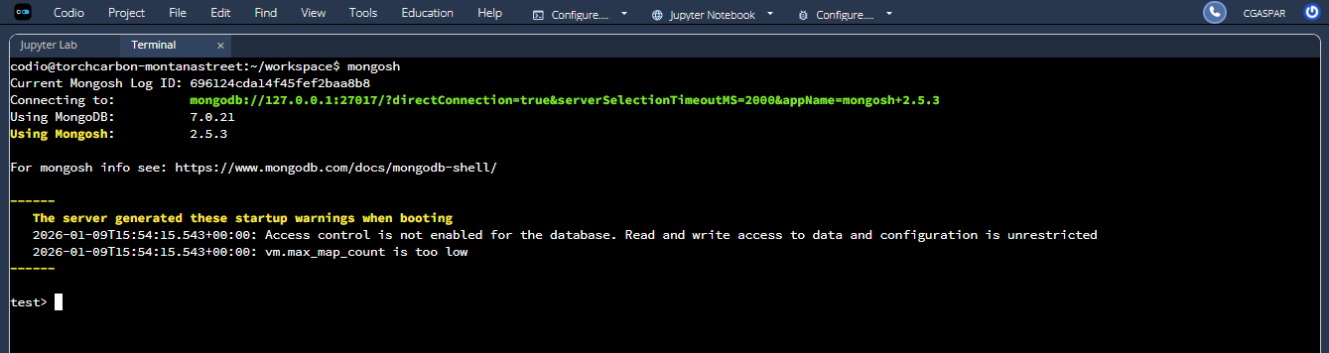
After the Mongo Shell opened, I exited back to the Linux terminal, navigated to the datasets folder, and then imported the database.
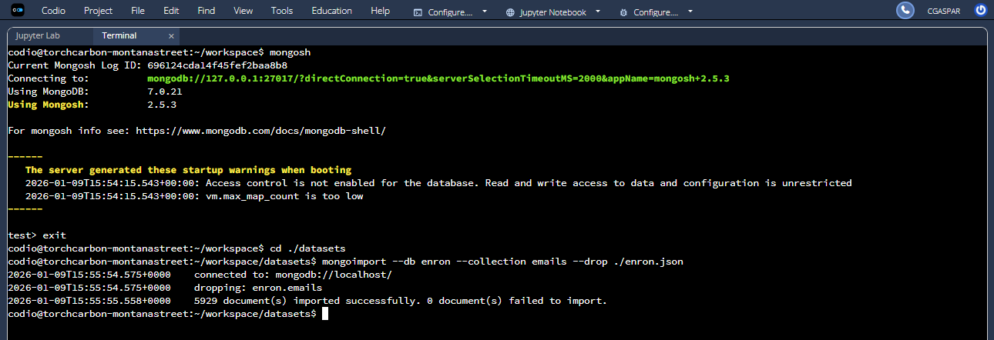
After importing the database, I started the Mongo Shell again, ran the “show dbs” command to list the directory of databases, set the database to the enron database using the “use enron” command, listed the directory of collections using the “show collections” command, and retrieved a document from the emails collection using the “db.emails.findOne()” command.
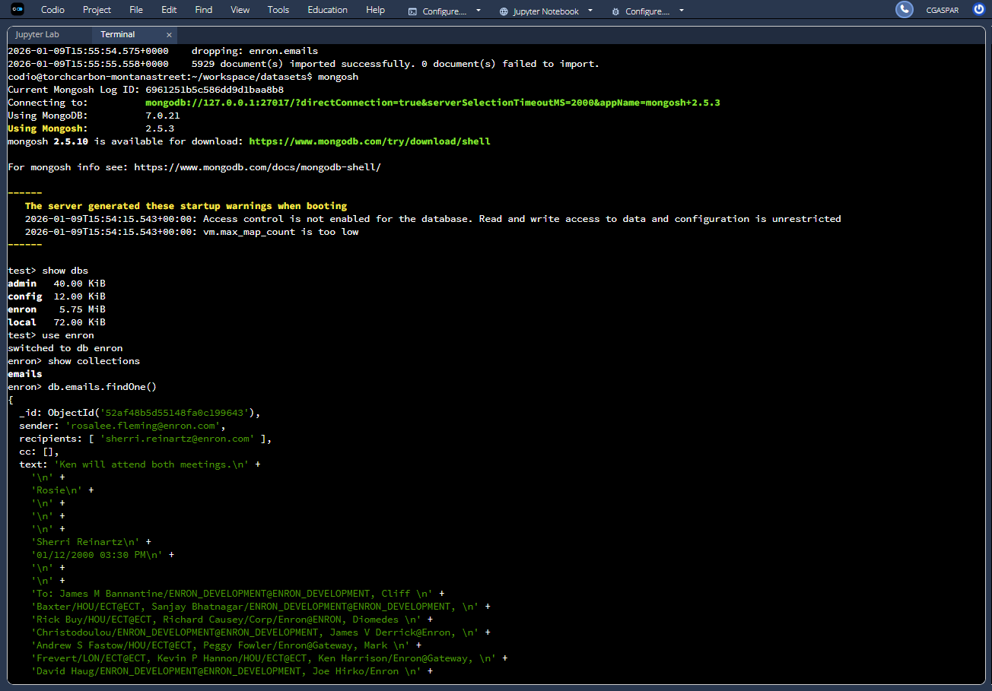

I ran the “snippet install mongocompat” command, and then ran the “Object.bsonsize(db.emails.findOne())” command to find the size of one email.
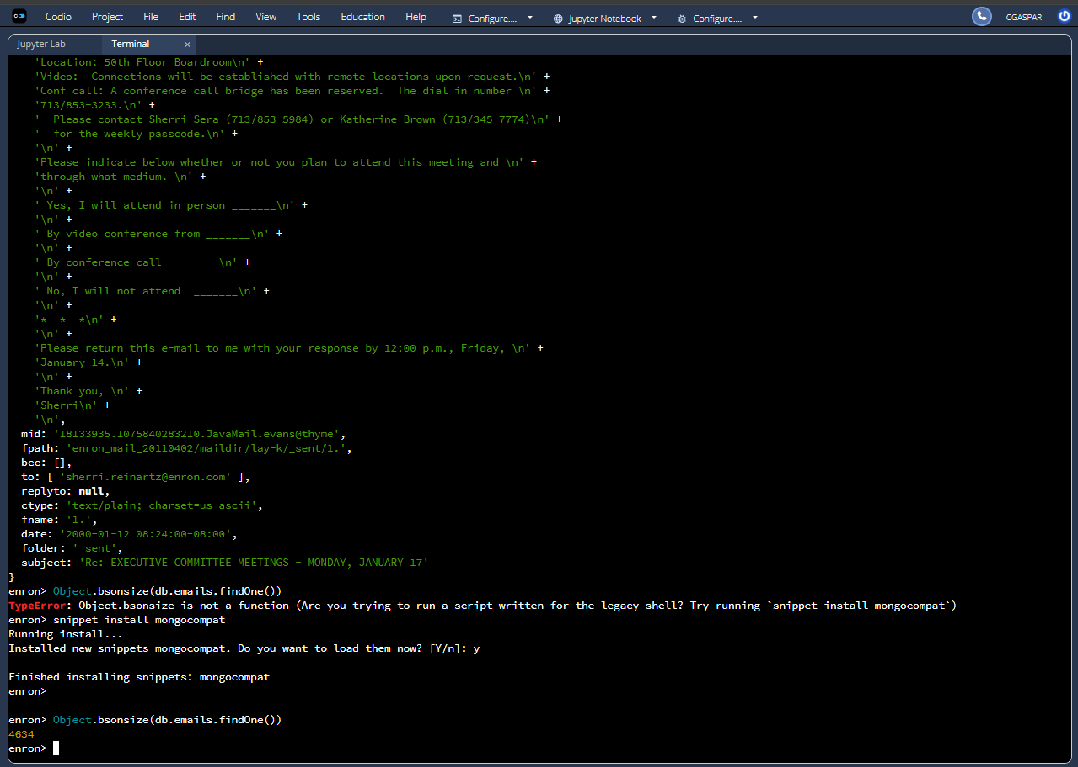

Finally, I ran the “db.emails.stats().size” command to find the total size of the emails collection.
